Case 5: Private placement process ( for Group 9 & 10)
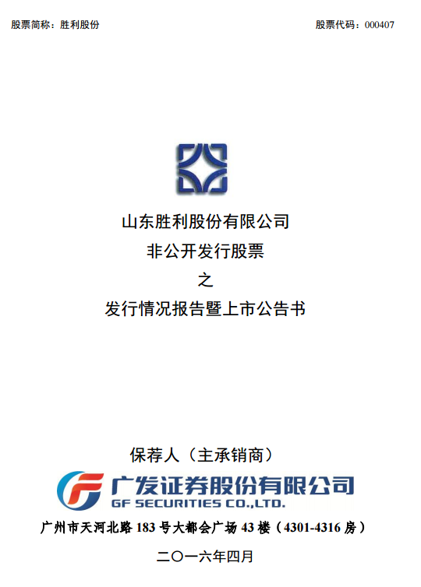
http://search.iwencai.com/stockpick/search?preParams=&ts=1&f=1&qs=zgxgrh_zfrgfs&querytype=&tid=stockpick&w=000407+%E5%A2%9E%E5%8F%91%E8%AE%A4%E8%B4%AD%E6%96%B9%E5%BC%8F

Tasks:
- What is the current private placement procedure in China?
- Using the prospectus of Shengli Corp. as an example, briefly explain the general structure of a private placement prospectus. Which part do you think is most relevant to the investors?
- There are couples of important dates involved during the private placement procedure. Which one do you think is most important to the investors?
- Does the identities of institutional investors/controlling shareholders in the private placement matter? Why? How about the share distribution among the institutional investors/controlling shareholders in the private placement?
- How did market react to this private placement?

CASE 6: Treasury bond issuance (for group 11 & 12)
Chinese Domestic government debts
http://gks.mof.gov.cn/redianzhuanti/guozaiguanli/

http://www.chinabond.com.cn/d2s/index.html

Tasks:
- What is the treasury issuance procedure in China?
- There are three types of bonds available in China: certificated bonds （凭证式国债）, Book-entry treasury bonds (记账式国债), and Savings Bonds (电子式储蓄国债). What are the difference among these three? Please explain it in detail.
- How do you justify the difference in investment return for these 3 types of bonds even when they have same maturity and same coupon payment frequency?
- What is the current investment return for local government bond? How do you justify the difference in investment return across provinces?

P.S. Our research lab provides access to Wind, CSMAR, Bloomberg, Capital IQ, ThomsonOne and datastream from where you can get the industry/financial/underwriter information. The lab is located at #303-305, Guanghua Building No.1.

Remarks:
- This is an open case study, therefore there is no absolute “correct” answer. The grade for the case will depend on how carefully you conduct the investigation and how convincing your result is.
- If you have any technical problem, please feel free to contact TA. He would be more than happy to help.
- The presentation of case will be conducted in the last hour of our class. Each case has strictly 25 min. Only 1 group will be selected to do the presentation for the case, and the other group will have 5 min to add their unique comments/points.
- As spoken, each group only has a single mark. So distribute your work wisely among the members. Also, you can decide who/how you do the presentation.
- Hope you enjoy doing the case.

